Jupyter – SAS Kernel – auto-completion errors

Kernel.py : <https://raw.githubusercontent.com/sassoftware/sas_kernel/master/sas_kernel/kernel.py>

Kernel.py in my installation : C:\tools\anaconda3\Lib\site-packages\sas_kernel

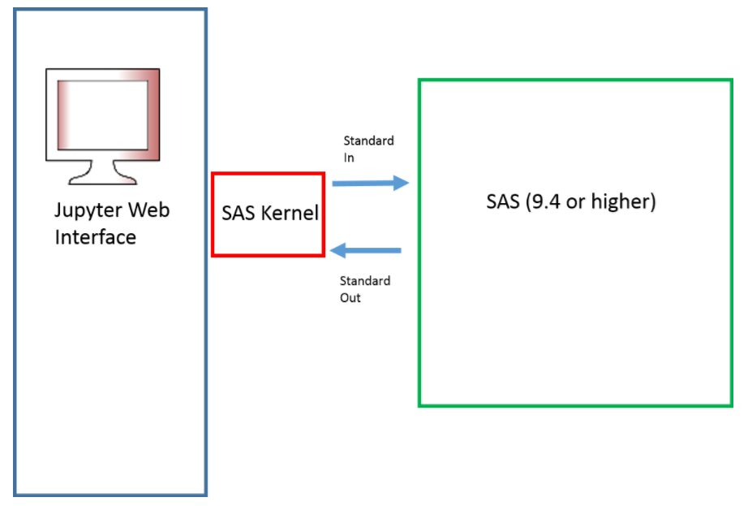

* Jupyter notebook is a framework that allows users to submit code to a computational engine (Kernel) and display results inline
* The SAS Kernel is a few hundred lines of python code that facilitates communication between the Jupyter notebook and SAS
* SAS communicates with the SAS Kernel through stdin, stdout, and stderr using the ODS HTML5 engine
* The SAS Kernel has no use without access to SAS

Table des matières

1) Case 1 – Test of PROC auto-completion 2

Using SAS standard kernel.py file 2

2) Case 2 – Test of DATA STEP auto-completion 3

Using the standard kernel.py file 3

Using a modified SAS standard kernel.py file 3

# Case 1 – Test of PROC auto-completion

## Using SAS standard kernel.py file

#### **Test**

When you ask to complete a PROC name in jupyter, it works, but not but the parameter of the procedure.

1. I type the first letter of PROC and type touch “<tab>”

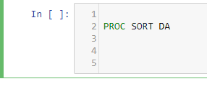

No suggestion appears and an error appears in SAS Kernel log (SAS kernel of Anaconda/Python server).

* **Error “TypeError: must be str, not bytes” appears.**

|  |
| --- |
| [IPKernelApp] ERROR | Exception in message handler:  Traceback (most recent call last):  File "C:\tools\anaconda3\lib\site-packages\ipykernel\kernelbase.py", line 235, in dispatch_shell  handler(stream, idents, msg)  File "C:\tools\anaconda3\lib\site-packages\ipykernel\kernelbase.py", line 434, in complete_request  matches = self.do_complete(code, cursor_pos)  File "C:\tools\anaconda3\lib\site-packages\metakernel\_metakernel.py", line 508, in do_complete  matches.extend(self.get_completions(info))  File "C:\tools\anaconda3\lib\site-packages\sas_kernel\kernel.py", line 221, in get_completions  method = str(procer.group(0).split(' ')[-1].upper()) + mykey.encode()  TypeError: must be str, not bytes |

#### **Python code extract :**

|  |
| --- |
| if proc:  # we are not in data section should see if proc option or statement  lastsemi = info['code'].rfind(';')  mykey = 's'  if lastproc > lastsemi:  mykey = 'p'    procer = re.search('(?i)proc\s\w+', info['code'][lastproc:])  method = procer.group(0).split(' ')[-1].upper() + mykey.encode()  mylist = self.compglo[method][0]  potentials = re.findall('(?i)' + info['obj'] + '.+', '\n'.join(str(x) for x in mylist), re.MULTILINE)  return potentials |

# Case 2 – Test of DATA STEP auto-completion

## Using the standard kernel.py file

When you ask to complete a DATA STEP statement in jupyter, it doesn’t work.

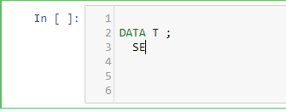

Jupyter interface didn’t suggest statement.

* **Error “IndexError: list index out of range” appears.**

|  |
| --- |
| [IPKernelApp] ERROR | Exception in message handler:  Traceback (most recent call last):  File "C:\tools\anaconda3\lib\site-packages\ipykernel\kernelbase.py", line 235, in dispatch_shell  handler(stream, idents, msg)  File "C:\tools\anaconda3\lib\site-packages\ipykernel\kernelbase.py", line 434, in complete_request  matches = self.do_complete(code, cursor_pos)  File "C:\tools\anaconda3\lib\site-packages\metakernel\_metakernel.py", line 508, in do_complete  matches.extend(self.get_completions(info))  File "C:\tools\anaconda3\lib\site-packages\sas_kernel\kernel.py", line 217, in get_completions  method = procer.group(0).split(' ')[-1].upper() + mykey.encode()  TypeError: must be str, not bytes |

|  |
| --- |
| if info['line_num'] > 1:  relstart = info['column'] - (info['help_pos'] - info['start'])  else:  relstart = info['start']  seg = info['line'][:relstart]  if relstart > 0 and re.match('(?i)proc', seg.rsplit(None, 1)[-1]):  potentials = re.findall('(?i)^' + info['obj'] + '.*', self.strproclist, re.MULTILINE)  return potentials  else: |

## Using a modified SAS standard kernel.py file

#### **Test**

1. I changed just this row of Python script :

From:

if relstart > 0 and re.match('(?i)proc', seg.rsplit(None, 1)[-1]):

To:

if relstart > 0 and re.match('(?i)proc', 'fixed_string'):

1. I type the first letter of PROC and type touch “<tab>”

When you ask to complete a PROC name in jupyter, it doesn’t work with this dirty modification. My modification breaks the completion for PROC <name>.

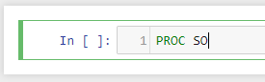

I receive this error :

|  |
| --- |
| [IPKernelApp] ERROR | Exception in message handler:  Traceback (most recent call last):  File "C:\tools\anaconda3\lib\site-packages\ipykernel\kernelbase.py", line 235, in dispatch_shell  handler(stream, idents, msg)  File "C:\tools\anaconda3\lib\site-packages\ipykernel\kernelbase.py", line 434, in complete_request  matches = self.do_complete(code, cursor_pos)  File "C:\tools\anaconda3\lib\site-packages\metakernel\_metakernel.py", line 508, in do_complete  matches.extend(self.get_completions(info))  File "C:\tools\anaconda3\lib\site-packages\sas_kernel\kernel.py", line 217, in get_completions  method = procer.group(0).split(' ')[-1].upper() + mykey.encode()  TypeError: must be str, not bytes |

1. I type the “DATA X;” completely and ask completion for DATA STEP statements.

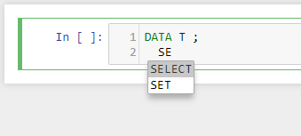

It works for DATA STEP now.