Snowflake OAuth Integration Setup Guide
Customer Side Configuration
Step 1: Create a Security Integration in Snowflake
Execute the following SQL command to create a Snowflake OAuth security integration:
CREATE SECURITY INTEGRATION my_snowflake_oauth_integration_a
TYPE = OAUTH
ENABLED = TRUE
OAUTH_CLIENT = CUSTOM
OAUTH_CLIENT_TYPE = 'CONFIDENTIAL'
OAUTH_REDIRECT_URI = 'https://localhost:8080/oauth/callback'
OAUTH_ISSUE_REFRESH_TOKENS = TRUE
OAUTH_REFRESH_TOKEN_VALIDITY = 7776000;

Step 2: Retrieve OAuth Client Secrets
Run the following SQL command to get the client credentials:
DESC SECURITY INTEGRATION 'MY_SNOWFLAKE_OAUTH_INTEGRATION_A';
Response:
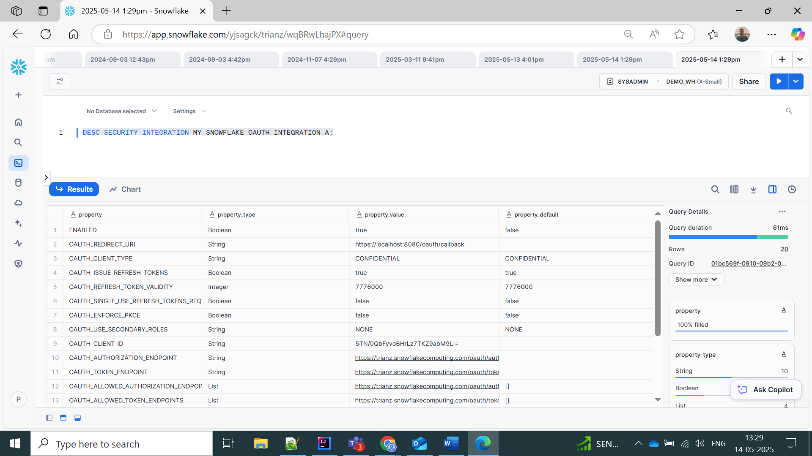
SELECT SYSTEM$SHOW_OAUTH_CLIENT_SECRETS('MY_SNOWFLAKE_OAUTH_INTEGRATION_A');
Example response:
{
"OAUTH_CLIENT_SECRET_2": "tep34/hPrrrrrFhyH71uWONS1GxAk=",
"OAUTH_CLIENT_SECRET": "TXRIiauQcNFVrrrxjRO177AkfPhyT/s8dDZU9LA=",
"OAUTH_CLIENT_ID": "5TN/0QbFrrrrz7TKZ9abM9LI="
}

Step 3: Authorize User and Retrieve Authorization Code
Open the following URL in a browser:
https://trianz.snowflakecomputing.com/oauth/authorize?client_id=< OAUTH_CLIENT_ID >&response_type=code&redirect_uri=https://localhost:8080/oauth/callback
- Sign in using your Snowflake credentials.
- Grant the requested permissions.
- You will be redirected to the callback URI with an authorization code in the URL, e.g.:
https://localhost:8080/oauth/callback?code=C72529FE82364Brrrrrrrrrrr854897668B99ADBB
Copy the code parameter.

Step 4: Save Credentials for Token Exchange
Store the following values securely for the connector:
- OAUTH_CLIENT_ID as client_id
- OAUTH_CLIENT_SECRET as client_secret
- auth_code (from Step 3)
- token_url: https://<snowflake_account_name>.snowflakecomputing.com/oauth/token-request from step 2
- redirect_uri: form step 1 integration query
- username: Snowflake username
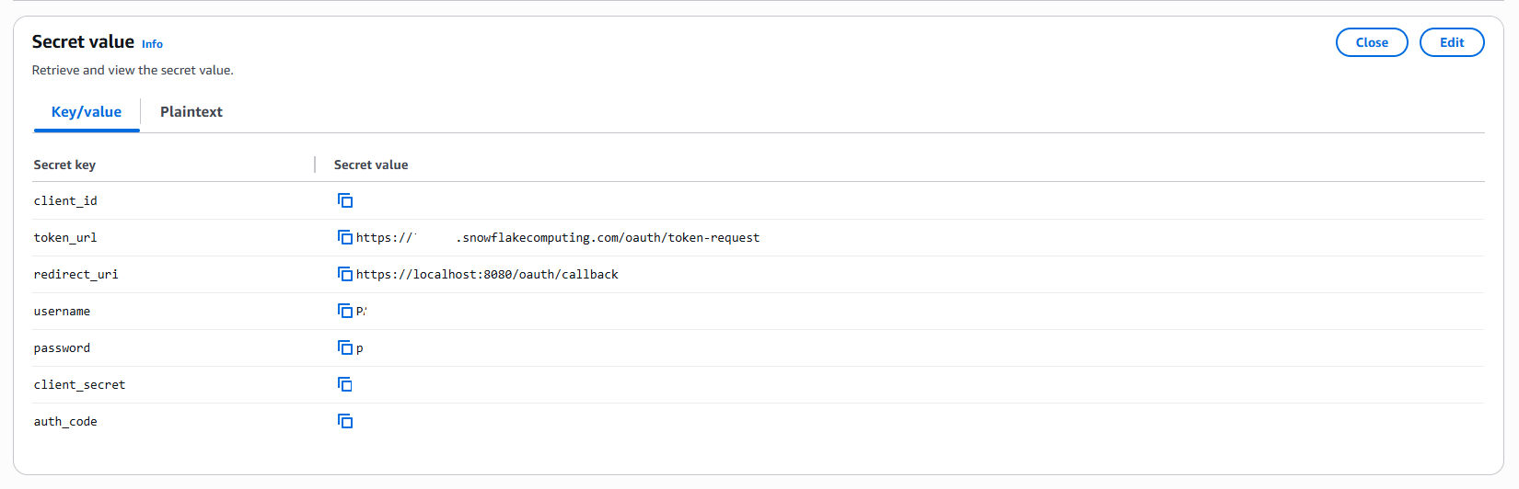

Connector Side Configuration
Step 5: Exchange Authorization Code for Access Token
Make a POST request to the token endpoint:
URL:
https://<account>.snowflakecomputing.com/oauth/token-request
Headers:
Content-Type: application/x-www-form-urlencoded
Body (x-www-form-urlencoded):
grant_type=authorization_code
&code=C72529FE82854897668B99ADBB
&redirect_uri=https://localhost:8080/oauth/callback
&client_id=5TN/0QabM9LI=
&client_secret=TXRIiauQAkfPhyT/s8dDZU9LA=
Sample Response:
{
"access_token": "ver:1-hint:4869...A==",
"token_type": "Bearer",
"expires_in": 599,
"refresh_token": "ver:2-hint:4869...A==",
"refresh_token_expires_in": 7775999,
"scope": "refresh_token session:role:SYSADMIN",
"username": "PARIKEM",
"idpInitiated": false
}

Step 6: Connect to Snowflake Using JDBC and Access Token
Use the access_token to establish a JDBC connection. Example JDBC URL:
jdbc:snowflake://<account>.snowflakecomputing.com/?authenticator=oauth&token=<access_token>
Replace <account> with your Snowflake account name and <access_token> with the actual token received in Step 5.

