Snowflake Testing With 3 Types of Authentications
Case 1: Default (Username and Password)
Secret with Username and password.
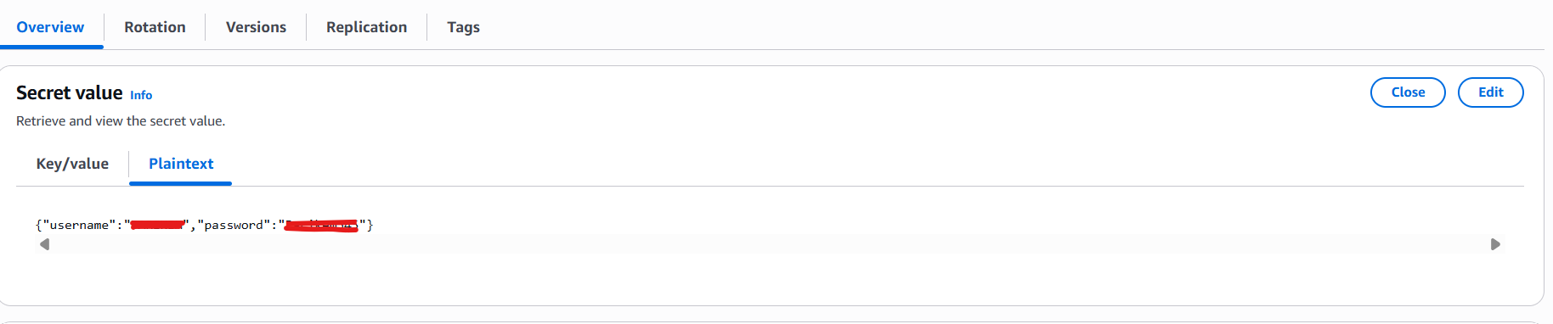
Query Id: c21681ad-9985-4fb2-bbf1-75c32c5b8a56
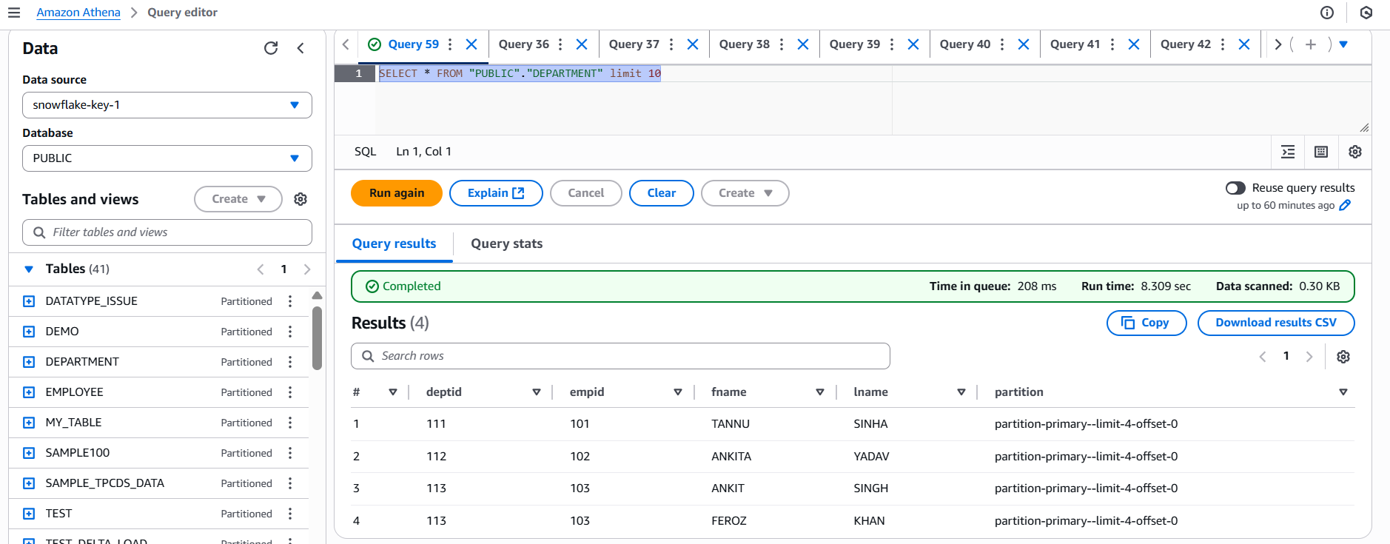

Case 2: Snowflake-OAuth
Secret with auth_code and other required fields.
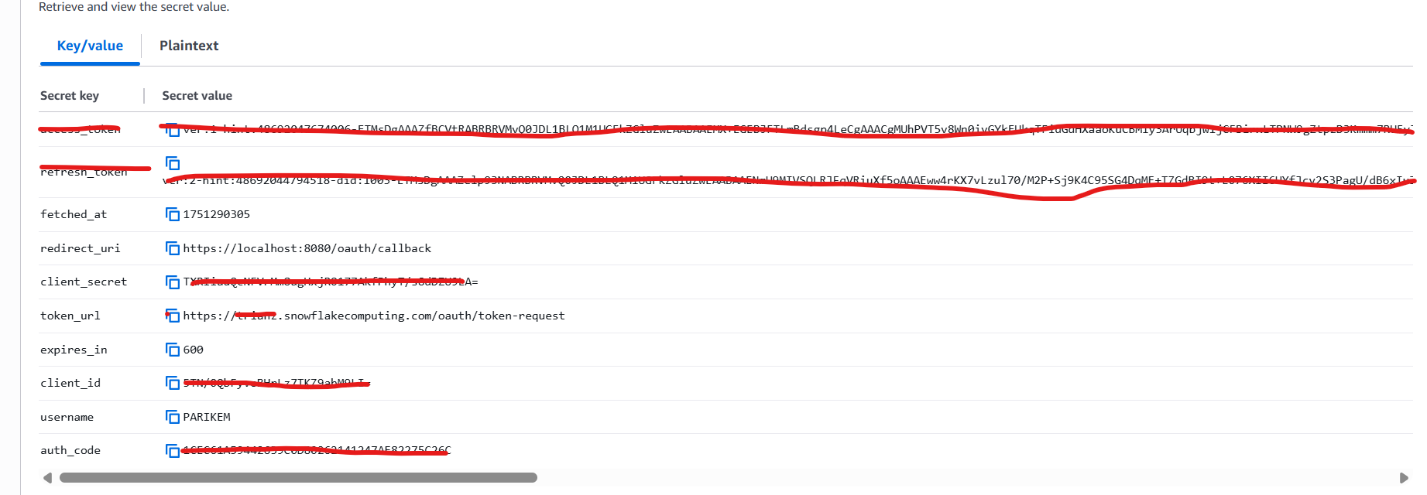

Query Id: 60645d27-027a-4970-b513-5037947bd337
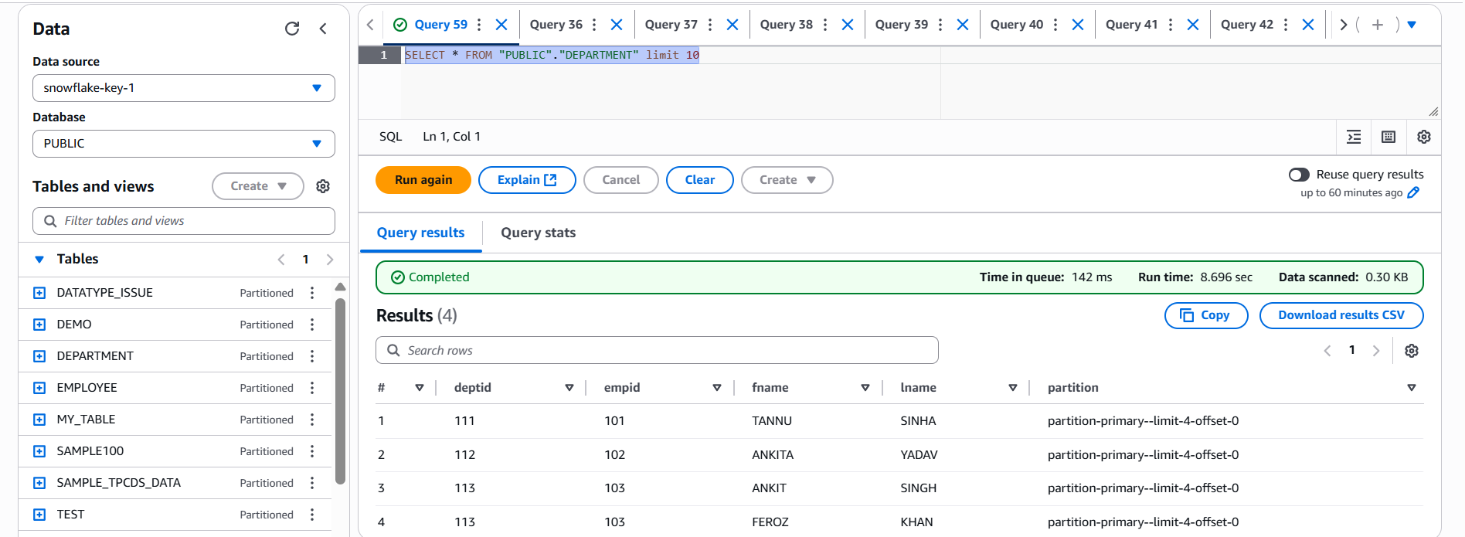

Case 3: Key-Pair Auth
https://docs.snowflake.com/en/user-guide/key-pair-auth
Secret with privateKey and username
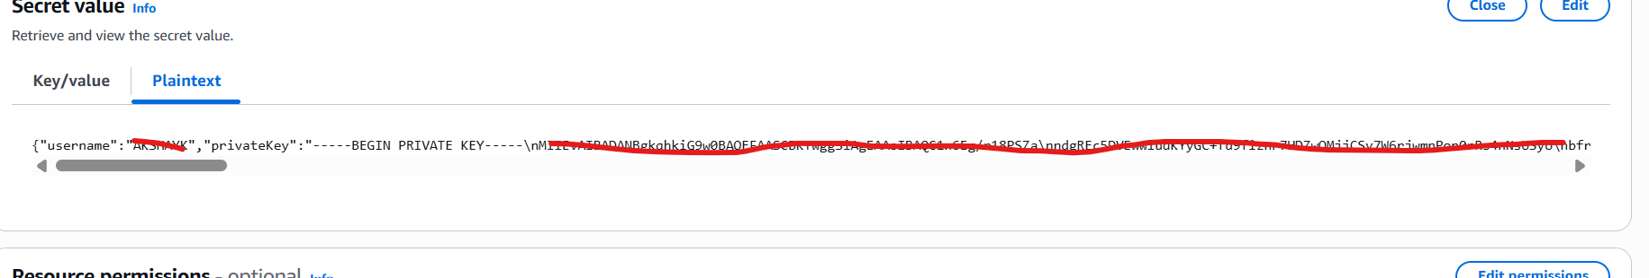

Query Id: c8680505-cb74-4039-a6f3-f494777b2518
