Athena Synapse Connector Testing with OAuth and Default Username/Password Authentications

1) With OAuth:

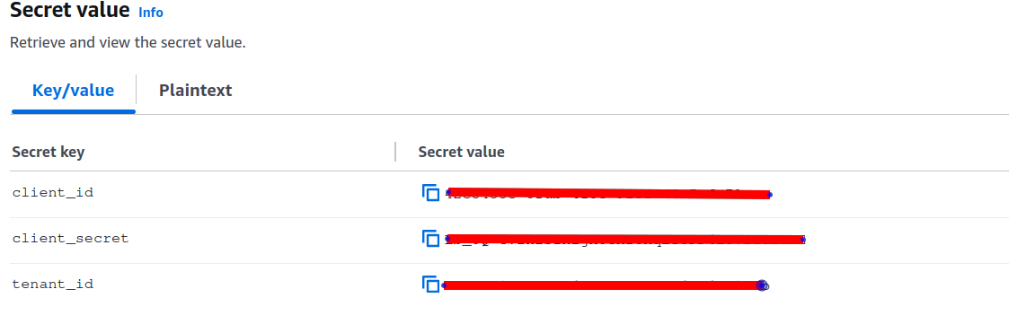

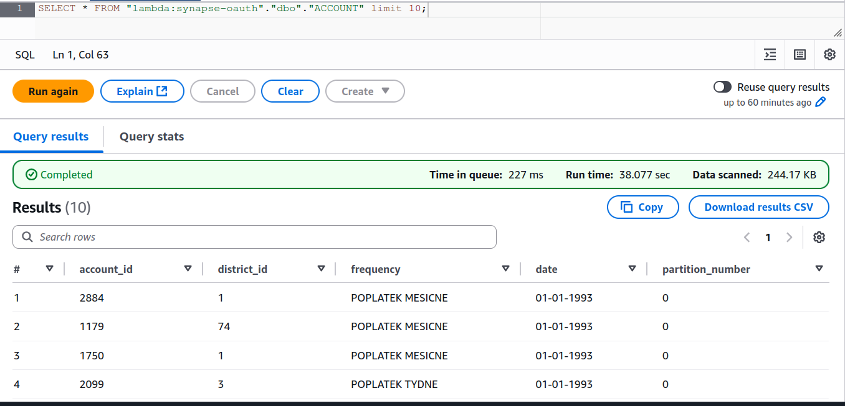
2) With Default Username/Password:



