DatalakeGen2 serverless support
Overview
Applied Azure serverless environment compatibility fixes to the athena-datalakegen2 connector, based on similar changes from [PR #698](https://github.com/awslabs/aws-athena-query-federation/pull/698) for the synapse connector.

Changes Made
- DataLakeGen2Util (New)
  - Detects Azure Serverless by checking "ondemand" in JDBC URL.
  - Added checkEnvironment(String url) using regex.
- DataLakeGen2Constants
  - Added SQL_POOL = "azureServerless".
- DataLakeGen2MetadataHandler
  - Updated getSchema() to fetch columns via direct SQL query in serverless mode.
  - Avoids getColumns() to prevent driver errors.
- DataLakeGen2RecordHandler
  - Updated readWithConstraint() to skip setAutoCommit(false) and commit() in serverless mode.
  - Prevents @@TRANCOUNT errors during cleanup.

Test:
Normal flow:
Execution Id:
25617861-3827-482e-9984-9b591dffcf31
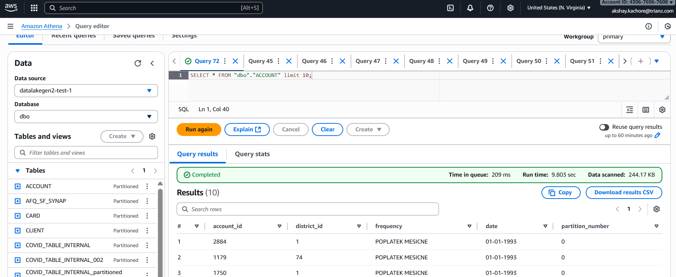

Serverless:
url : datalakegentwo://jdbc:sqlserver://xxxxx-ondemand.sql.azuresynapse.net:1433;${synapse-xxx-xx}
Before fix:
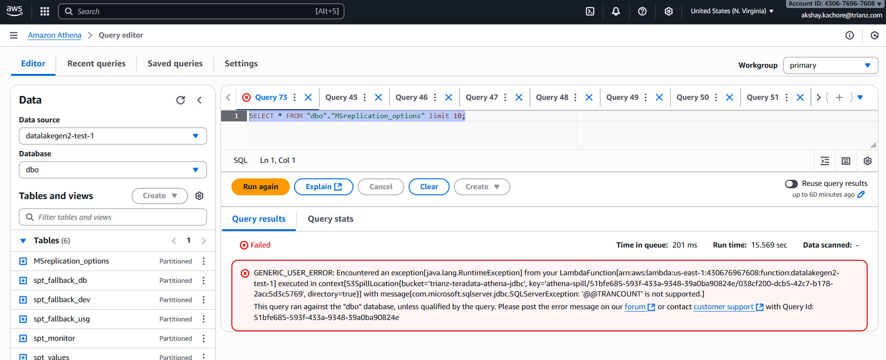

After fix:
Execution Id: c1d02429-2313-4045-a1f5-7d1b037049da

