Test after removing timestamp case from SnowflakeQueryStringBuilder.
Column type: timestamp
S3 export enabled:
Query:
SELECT * FROM "PUBLIC"."ALL_DATATYPES" where COL_TIMESTAMP >= TIMESTAMP '2023-12-20 00:15:00.000';
Execution Id: c2877108-f7f1-4e13-acb0-1c378ea4d682
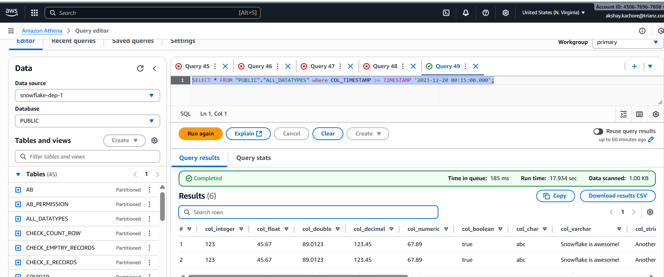

S3 export disabled:
Query:
SELECT * FROM "PUBLIC"."ALL_DATATYPES" where COL_TIMESTAMP >= TIMESTAMP '2023-12-20 00:15:00.000';
Execution Id: 8917549f-24a2-4eee-ae84-417c297a9871
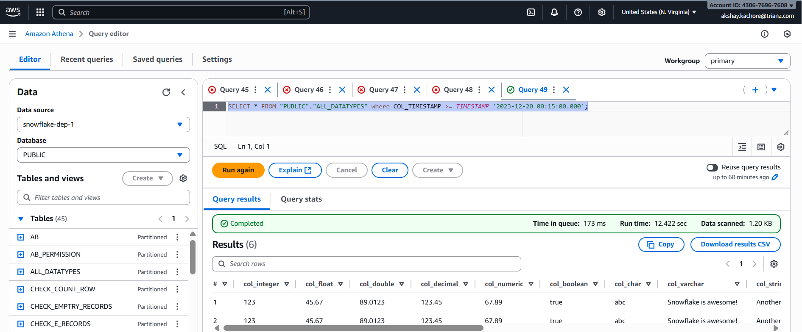

Column type: timestamp_tz
S3 export enabled:
Query:
SELECT * FROM "PUBLIC"."test_timezone" WHERE event_time_tz >= TIMESTAMP '2024-01-01 12:00:00 +0000'
Execution Id: c1216e14-1924-4502-96af-228a624e4c77

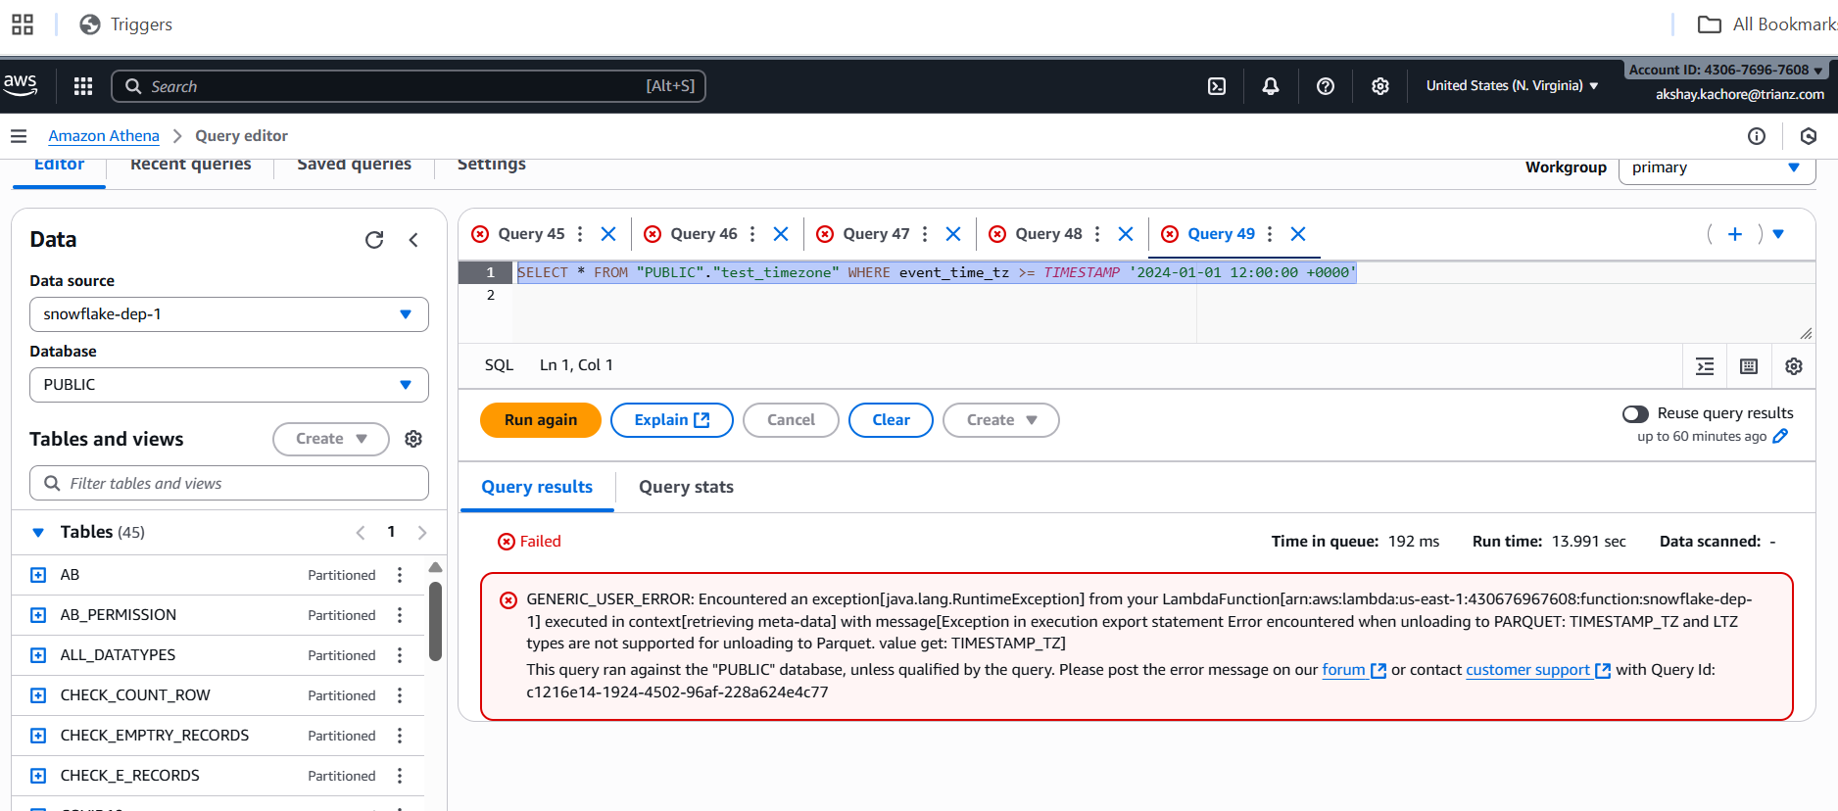

S3 export disabled:
Query:
SELECT * FROM "PUBLIC"."test_timezone" WHERE event_time_tz >= TIMESTAMP '2024-01-01 12:00:00 +0000'
Execution Id: 544cfa5a-d43b-424f-84d4-8909afa6dfb4
